RR Case Study Part 1 - Management Reports

Problems with the Paper Based System at Ray’s Rentals

* Paper based systems take much longer to update and maintain, in-comparison to a computer based system.
* There are too many paper-documents to organise and limited storage space.
* Changes have to be made manually which can get unorganised as records have to be crossed/scribbled out.
* Handwriting may get too unprofessional and difficult to understand because of this services are ignored.
* There is no reasoning in having two separate records for the same 150 bikes.
* Records of past services on the bikes may get lost as there’s no form of “back-up” unlike organising files on a computer based system.
* The amount of time the bike has been rented out is not accurate due to the customer giving an estimate of time it has been rented out for.
* There will be difficulty to query/manually search and organise through specific records.
* Bike part receipts are all kept in a little cabinet leading to random orders being given to the service team because of this parts are over ordered or there are no parts at all, this is wasting a lot of money.
* The system does not keep a record of the spare parts which are needed for repairs, this leads to items being frequently out of stock.
* There are no records to confirm if a bike has been serviced before.
* There is little form of security, records have to be locked away as there is no kind of encryption.
* No separate system for reservations.

Requirements

* Build a computer-based relational database which can be allocated between the different departments within the business.
* Make certain of the relational database being normalised so that the database is organised to reduce any redundancy & dependency of data, as normalization divides larger tables to smaller ones which can be linked together.
* Ensure that all of Ray’s colleagues are able to access the database through some form of interface.
* Create reports which can be made and organised by using queries to filter out the information that the employees may and may not require.
* Ensure the database can make forms suited to each departments needs.
* Have separate tables for reservations, bike parts, etc; each table must have a title relevant to the table, e.g, a reservation table must store the Rent Date, Customer Name, Customer Address, Postcode, Phone Number, Bike Class, and Size.
* It should record all bikes in stock (approximately 150 bikes or so for hiring).
* Each bike must have a unique ID number to found on the database.
* Bike records must have details of the model, its manufacturer, the date which Ray bought them, how much Ray paid for it and which classification of size it belongs to.
* Maintenance history of the bike is kept on the bike record, disposal details are also kept on bike record and records are kept a further two years after the bike has been sold before they get deleted.
* Rental record must store dates, times, customer details and the amount paid for hiring.
* Separate system for reservations must store Rent Date, Customer Name, Customer Address, Postcode, Phone Number, Bike Class, and Size.
* The table for storing the spare parts required for servicing must include an item ID, the amount of stock, and so on.

Data Enquiries and Management Reports

**Management Reports:**

Management reporting is a process carried out within a business that has information systems in place, there are a few different types of management reports, which include:

* Analysis Reports
* Exception Reports
* Key Target Reports
* Ad-hoc Reports

**Analysis Reports:**

An analysis report summarises data from a certain period of time, they are usually presented on a two-dimensional table, for example, you may have a analysis on sales for particular months **(Figure 1.0)**:

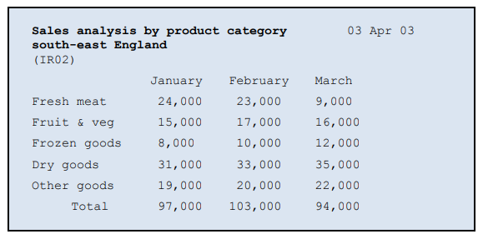

**Figure 1.0:** Analysis report - sales by product category - (*Whiteley, 2013)*

**Exception Reports:**

An exception report is designed to locate issues that need resolving; it is a type of management report that only displays information that meets a specific criteria, for example, you could have an invoice which highlights the companies that have paid for their order or those who have not. **(Figure 1.1)**:

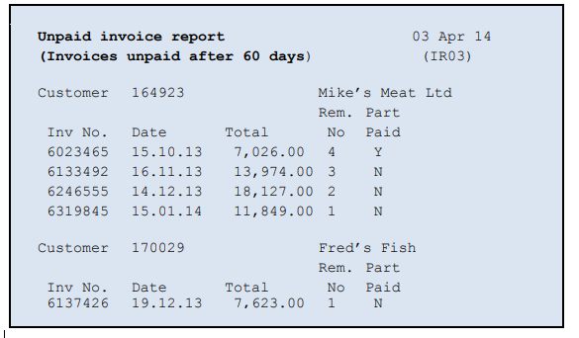

**Figure 1.1:** Exception report - unpaid invoices - *(Whiteley, 2013)*

**Key Target Reports:**

Key target reports compare current performance to pre-set targets. These targets must be achievable and specific in order to be effective in aiding improvement. For example, a key target report could be made for a warehouse **(Figure 1.2)**.

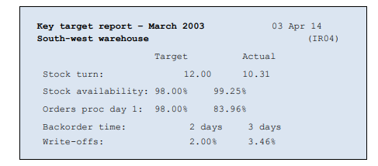

**Figure 1.2:** Key target report - *(Whiteley, 2013)*

**Ad-hoc Reports:**

Ad-hoc reports are essentially produced on demand or whenever the data is needed. An example would be if a manager of a company needed to find out who purchased a certain product on a certain date.

**Data Enquiries:**

Data enquiring is a process which is used to collect information from a database, users, and other software. Depending on the enquiry, users can usually request several different types of data from well-known sources or from databases in order to get data which they can then turn into information that more suit their needs. In the case of Ray’s Rentals, a member of staff in the shop may need to know if a bike has a reservation for it on a particular date.

Sources that provide data usually structure their information and data into different types of attributes, this is called a data definition. Data definitions specify information into data which follows certain attributes, for example: ‘Name, Caption, Description, Data Type, Range and Default Value’ *- (Cossac, 2011).*

Data Enquiries and Management Reports for Ray’s Rentals

**Analysis Report examples for Rays Rentals**

1. How many of each bike type rented per month.
2. How many total rentals per month.

Example:

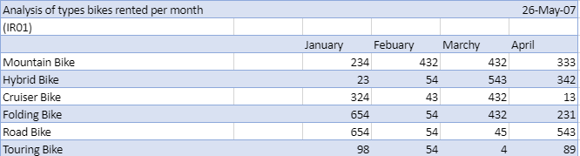

**Exception Report examples for Rays Rentals**

1. Damages & faulty bikes.
2. Older bikes that need to be sold.

Example:

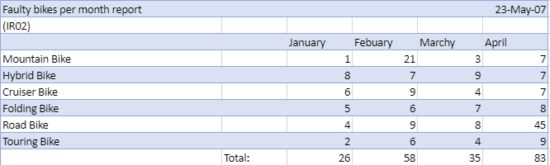

**Key Target Report examples for Rays Rentals**

1. Rentals per week/month/year.
2. Availability and demand of bike types per month/week

Example:

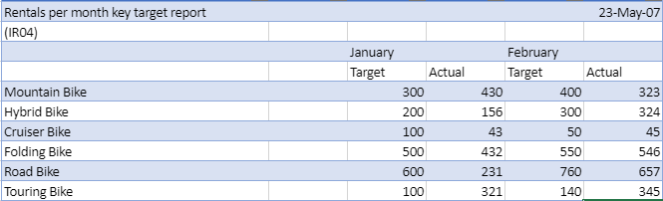

**Ad-hoc Report examples for Rays Rentals**

1. On request info about bikes/ rentals for staff
2. How long is bike typically rented for.

Example:

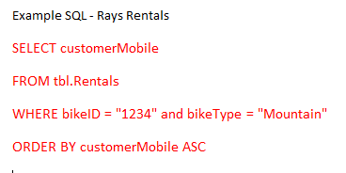

**Data enquiries that can be useful to Ray’s Rentals**

Members of staff for Ray’s Rentals need to search up and give customers their invoices from the database or send invoices from the database to the customer’s email, to do this the database must be designed to make reports or forms. The form should have a query to search up customer’s ID which will them to put the customer’s data and amount they need to pay on the form, forms can also be used for other enquiries, an invoice can also be printed out for customers to serve as a receipt for both the customer and the members of staff to show that it has been paid for.

Customers tend to enquire about specific products such as types of bikes and the prices and how much it will be to rent it out for a specific amount of time, because of this the the table will need to have a unique ID and type of bikes and with this the database should make up a form with the data which will lookup the type of bike requested and the price of it being rented out. Bikes will also need an enquiry query to check if bikes have reservations on certain times and dates to make sure there are no overlapping reservations by customers, each reservation should have the customer's name, billing address and other details to make sure that they are renting it out to the right customer.

Bikes may be out for service and because of this the members of staff needs a query to let them enquire which bikes are out for service and which bikes are currently in shop and ready to be rented out.

A query for spare parts is needed so that when the bikes are out for servicing the engineer can see if they have the required parts in stock and if they are able to conduct the service or not.

A query to search up the age of the bikes is needed this is to let staff know how old the bike is and how popular it is with the customer. The shop can decide on whether they should continue renting it out to customers or replace the bike with a newer model.

Reference List

* *Cossac, (2011) Tallis Training - Basic PROforma Concepts: Enquiries, Sources and Data Definitions. [Online] [Accessed on 15th October 2018]* [*http://archive.cossac.org/tallis/Basic_proforma_concepts08.htm*](http://archive.cossac.org/tallis/Basic_proforma_concepts08.htm)
* *Whiteley, D. (2013) An introduction to information Systems, Palgrave Macmillan.*